Introduction
67 residents of Blyth town enjoyed a learning and development programme called Wild and Wonderful Confidence and Empowerment programme, which had the below aims. People included came from various backgrounds, including, disadvantage, lone parents, people with visible and invisible disabilities, people in various stages of recovery from addiction, mental ill health and post trauma. The ages of everyone involved spanned 23 to 75 years.
Aims
- To increase confidence, self-belief and self-esteem of participants. In addition to enhance their feelings of adequacy, usefulness, overall wellbeing, and improvements in mental health.
- To provide a foundation of acceptance, optimism, increased resilience, and confidence, on which they could base their future journey upon, so they can move forward in their lives.
- To raise aspirations and contribute to the social and emotional wellbeing of themselves, and thus, their children and wider communities.
The core objectives for those participating was to:
- Increase Confidence
- Find Connection
- Break free from stuck points in life
- Build Self Belief
- Reduce Anxiety

Results of Project
Summarising previous reports, the results were astounding for participants who fully engaged and immersed themselves in the project. All participants, regardless of their involvement in the activities, left with more confidence and with feelings of empowerment and self belief. This was possible, because we had a large array of inclusion activities and moulded each programme, to the needs of the participants.
We found that everyone enjoyed their experiences, gave positive feedback, and left with skills and tools that were new, practical and useful to help them along their way.
Each group posed different challenges and joys, no one group required the same form of intervention as some groups thrived purely on crafts and creative endeavours like making clay recovery hearts, gifts and decorations to allow for relaxation, positive feedback and skills and confidence. Vision Board creations were enjoyed by everyone, the feedback from this was universal and high quality.
All of the vision boards we created can be seen by following this link to Facebook here….
https://fb.watch/rx_vAYJhdF/

Examples of feedback can be seen from each of the previous reports and some personal favourites are below.
On average participants scored their experiences of the programme 9.5/10
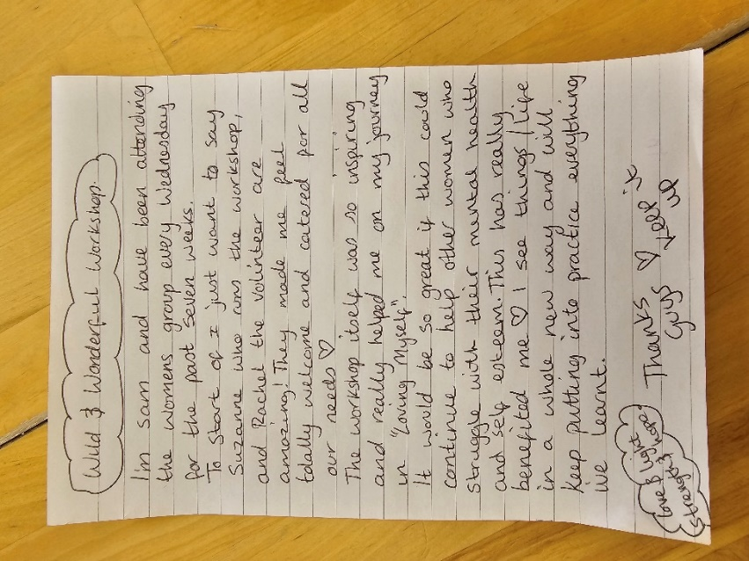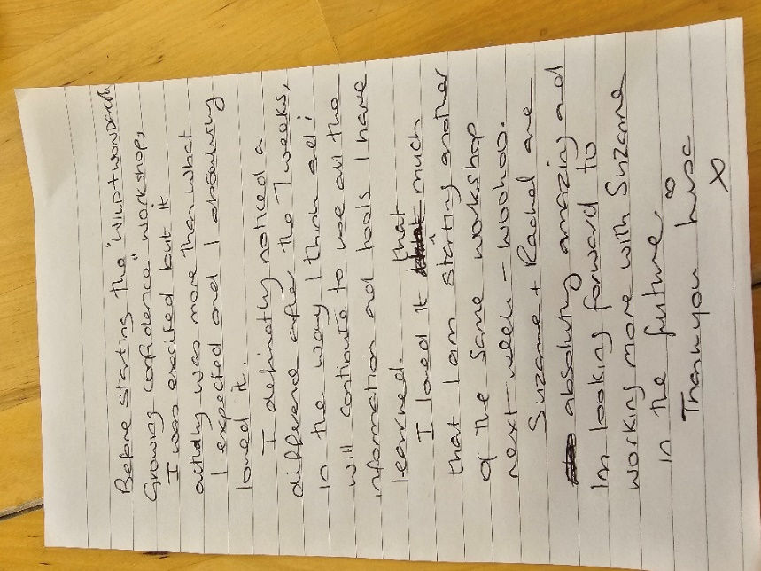
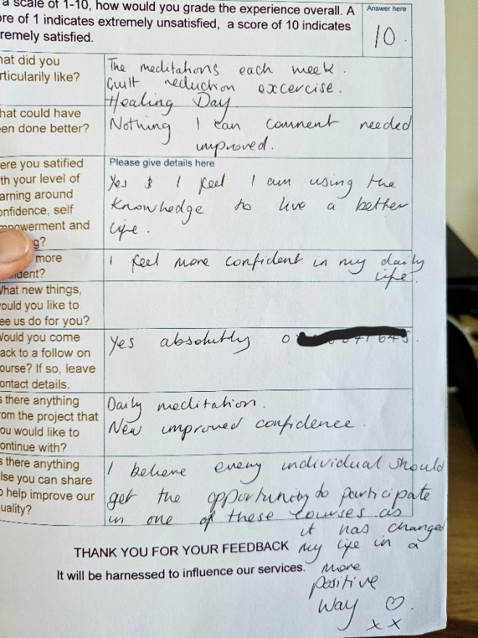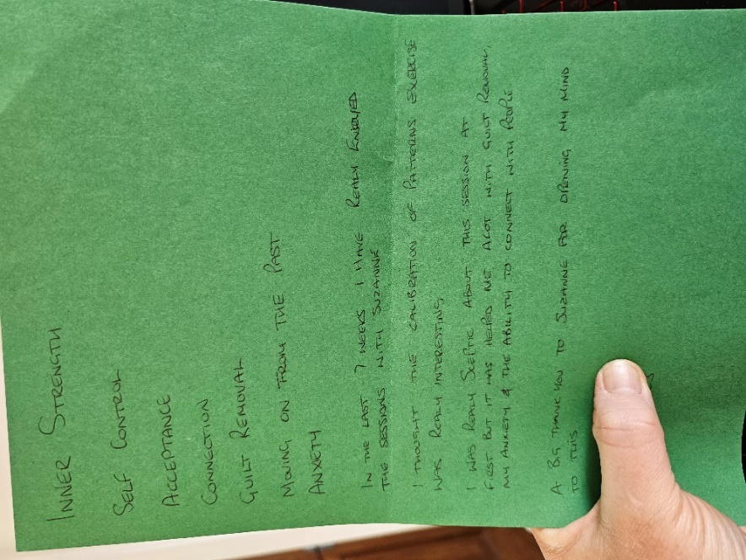

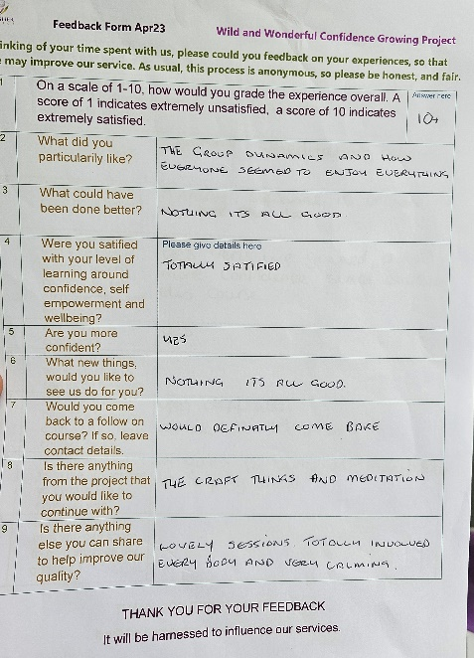

Some more participant words -
“I particularly liked the educational value of the programme, I have 100% changed and notice a difference.”
“I came to the group quiet and anxious. I am leaving with very little anxiety and definitely more confident”
“Absolutely satisfied, I am more confident and want to keep going”
“Definitely more confident, I loved it, and want to continue with more!”
“I liked it all, and will continue with meditation”

In total, over the year, 30 Levels of change have been measured, participants with the most changes, were the ones who attended all the sessions, engaged in all the activities and embraced the uniqueness of the programme. Their outcomes leaving the project, were more measurable. For example, Moving from addiction, to training as a psychotherapist, or moving from agoraphobia into full time employment.

Although all participants made changes, the below chart show the levels of change that were the most extreme.

Additional Information
During and after the programme, participants moved on in their lives, the below chart shows the overall outcomes for these participants.
Many participants were not engaged with society, they did not have any other form of intervention. Some didn’t trust other professionals and so, for the most vulnerable of our participants, entering into counselling, building bridges with friends or family, moving into community based care and support, or engaging with professional services to help them move forwards, was a huge part of our project and these outcomes were the most common.

Learning Points
Not many participants could commit to attending every session. Missing parts of the programme due to illness or other commitments, meant that some participants didn’t benefit completely from the offerings. Providing a regular, weekly drop in, over the period of the year, would have been a better way to retain engagement from participants who struggled to attend seven weekly sessions in a row.
One to one appointments were also missed, cancelled, or participants failed to attend. Again, offering consistent, weekly, sessions, may have changed this.
There was always a lot of post trauma survivors in each of the groups, this meant that the depth of their problems, required professional intervention such as psychotherapy or counselling. Working in Partnership with Someone Cares helped participants access deeper support. Learning from this, in future, an additional staff member, qualified in these skills, will allow for more measured success.
Thank you for this amazing project.

